**Chapter 15**

**Changing a Tire on a Car**

By: Misha Ward

Contents

Practicing Vehicle Maintenance 85

Planning for Preemptive Care 85

Preparing for Corrective Actions 85

Gathering Resources 86

Reviewing the Manual 86

Gathering the Tools 86

Executing the Tire Change 87

Setting up 87

Changing Tire 87

Cleaning Up 87

References 88

Appendix 88

Being successful at the University of Washington Bothell requires more than studying; getting to school on time and safely is also critical. Reading this chapter allows you to discover why changing a tire, like other car maintenance practices, has numerous benefits that include helping you be prepared for worst case scenarios and arrive to any class on time (especially during finals).

# Practicing Vehicle Maintenance

Vehicle maintenance is split into categories of preemptive and corrective maintenance.

## Planning for Preemptive Care

Car owners are expected to take care of their vehicle tires and ensure that they are in proper working order. Preemptive care, like keeping your tires inflated and wheels aligned, helps keep your car running smoothly and in a cost-effective way.

You are responsible for taking care of your car and knowing when your tires are too old and need to be replaced or filled with air.

## Preparing for Corrective Actions

Events like running over nails, malicious incidents, or improper care can cause your car to have deflated tires requiring you to fix your car to avoid costly tire alignments.

When issues arise, change the tire quickly to fix the tires for you to keep using the vehicle and prevent further damage and go to an auto store as soon as possible for further car support.

# Gathering Resources

Changing tires requires resources which is divided into reviewing the manual and gathering tools.

## Reviewing the Manual

Car owners usually keep their manual in easily located place like a glove compartment as the manual has all the information you would need to change a tire.

A car manual is the first place to consult when faced with manually changing a flat tire. When you notice your car leaking air or experience a flat tire on the highway, find your car manual and follow the steps to start replacing your tire.

## Gathering the Tools

Prepared drivers also have many tools which make changing a tire a quick and easy process. Being prepared can be the difference between being on time and late for class.

It is critical for you to periodically keep track of your tools, replacing old or damaged tools out. When you need to buy new tools, go to a respected retail outlet as their products work reliably. Table 1 shows a checklist of tools required and where to get them.

**Table 1: Resources, Tool Reference, and Checklist Guide**

| **Tool / Resource** | **Importance Ranking** | **Where to Find** | **Checklist** |
| --- | --- | --- | --- |
| **Car Manual** | **Critical** – Needed item for tire change, check each year to see if your manual is still up to date and accurate | Car Glove Box / internet | Image result for checkbox |
| **Spare Tire** | **Critical** – Needed item for tire change, need to check every year to see if its inflated | Trunk / Les Schwab | Image result for checkbox |
| **Jack** | **Critical** – Needed item for tire change, check every year to see if this item still works | Amazon.com/Target | Image result for checkbox |
| **Lug Wrench** | **Critical** – Needed item for tire change, check every year to see if this item still works | Amazon.com/Target | Image result for checkbox |
| **Cell Phone** | **High** – Important item, check every day to make sure your phone is charged so you could call someone if needed | AT&T, T-Mobile, etc. | Image result for checkbox |
| **Flashlight** | **High** – Important item, check every month to make sure flashlight is working | Target/Home Depot | Image result for checkbox |
| **Flares** | **Low** – Not critical, check every two years if you have flares to help alert other drivers to slow down | Home Depot/ Amazon.com | Image result for checkbox |
| **Gloves** | **Low** - Not critical, check every two years if your gloves need repairs to protect your hands | Amazon.com/Target | Image result for checkbox |
| **Wheel wedges** | **Low** - Not critical, check every two years if your wheel wedges still stop your car from rolling | Home Depot/ Amazon.com | Image result for checkbox |
| SOURCES*:*  [1] DMV.org. 2017. "How To Change a Tire". DMV. Web. Oct 18, 2017. <https://www.dmv.org/how-to-guides/changing-tire.php> | | | |

# Executing the Tire Change

Changing tires have distinct phases for ensuring a proper exchange of tires.

## Setting up

Setting up the area around you for changing a tire is necessary as it can help with preventing injuries and keeping other drivers safe from colliding with you. Additionally, setting up your car can help you quickly replace the tire and get going back to class.

Read the manual for steps on how to set up your car prior to changing the tires.

## Changing Tire

Changing the tire with orderly precision and following each step is critical when a flat has occurred. Thinking clearly allows one to remain safe and avoid additional car issues.

Remain calm, collected, and pay attention to your surroundings. Read each instruction in the manual or *Appendix A* carefully and be attentive in your steps.

## Cleaning Up

Although sometimes forgotten in the rush of getting somewhere, cleaning up your tools and materials prevents future accidents and littering. Additionally, cleaning up prevents you from having to replace tools or parts saving you money.

Be careful to avoid skipping steps in your manual and ensure that the area you have worked in is clear of any missing tire bolts or tools.

# References

CarsDirect. 27 Janauary 2012. "5 Advantages That New Tires Give You." *CarsDirect.* Web 20 November 2017. <https://www.carsdirect.com/car-repair/5-advantages-that-new-tires-give-you>

"How To Change a Tire When You’re Stranded". Convoy Auto Repair BLOG. 31 May 2012. Web. 20 November 2017. <https://www.convoyautorepair.com/blog/how-to-change-a-tire-when-you-e2-80-99re-stranded>

DMV.org. 2017. "How To Change a Tire". *DMV*. Web November 20, 2017. <https://www.dmv.org/how-to-guides/changing-tire.php>

Salzberg, L. 25 August 2013. "29 Simple Road Trip Hacks You Need To Know". *Buzzfeed*. Web 20 November 2017. <https://www.buzzfeed.com/lilis2/simple-road-trip-hacks-you-need-to-know?utm_term=.eeQ8o7awJ#.cmD8xmPby>

# Appendix

*Appendix A:*

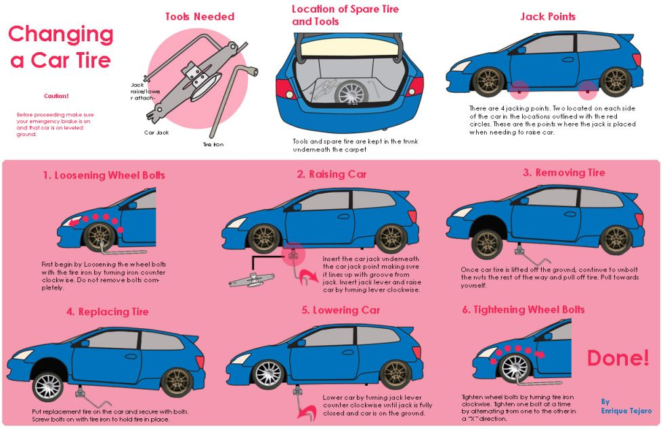

SOURCES*:* (Convoy Auto Repair BLOG)

[Word count 590] – This count excludes any words from *Table of Contents*, *Table 1*, and *References*.